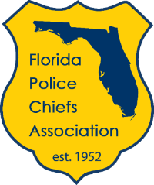

For Immediate Release:
Tuesday, April 26, 2022

Contact:
William Stander, (850) 212-3250, william@williamstander.com

Florida Police Chiefs Association Congratulates 2022 New Police Chief Seminar Graduates

Tallahassee, Fla. – The Florida Police Chiefs Association (FPCA) recently welcomed ten graduates of their 2022 New Police Chiefs Seminar, held at the FPCA headquarters in Tallahassee.

"One of the FPCA’s most important roles is to help prepare individuals for a chief executive position in law enforcement. On behalf of the Florida Police Chiefs Association, we congratulate each of the chiefs who completed the FPCA’s New Police Chiefs Seminar,” said FPCA president and Daytona Beach Shores Public Safety Department Director Stephan Dembinsky. “These individuals are the future of law enforcement leadership in Florida.”

Completing the seminar were:

- Chief Michael Balken, Ocala Police Department
- Chief David Brannon, Bunnell Police Department
- Chief Andrew Ethridge, Volusia County Beach Safety
- Chief Jerry Feltner, Lawtey Police Department
- Chief Tracy Frazzano, Marco Island Police Department
- Chief Elvis “John” Guzman, Green Cove Springs Police Department
- Chief Manuel Marino, Port Orange Police Department
- Chief Cyrus Robinson, Port Richey Police Department
- Chief Mark Smith, Panama City Police Department
- Chief Matt Tracht, Winter Springs Police Department

Funded by the Florida Police Chiefs Education and Research Foundation, Inc., a publicly supported 501(c)(3) non-profit, the Foundation provides conference scholarships and training grants for chiefs who are otherwise unable to fund their training and education due to agency budget constraints.
The New Police Chiefs Seminar is a keystone step in the FPCA’s professional development program. Because of the scope of their new job, recently appointed chiefs often find themselves confronting issues with which they have had little or no experience during their professional career. The seminar provides new chiefs with an understanding of those critical issues such as organizational culture and management, crisis management, dynamic change leadership, and the Florida Criminal Justice Standards and Training Commission disciplinary process.

“From our Communication, Organization, Roles/Responsibilities and Expectations (CORE) training, to our seminars for new and future chiefs, the Florida Police Chiefs Association is committed to providing quality professional development for Florida’s law enforcement executives,” said Coconut Creek Police Department Chief Butch Arenal, chairman of the FPCA’s Professional Standards Committee.

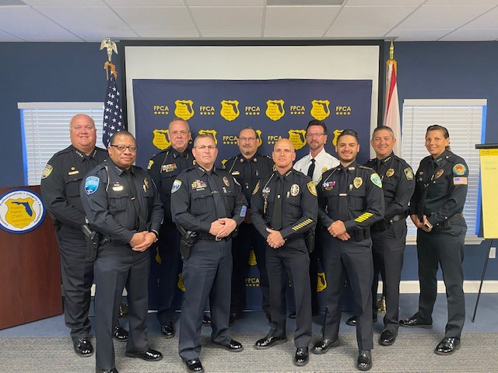

About the Florida Police Chiefs Association

The Florida Police Chiefs Association (FPCA) is the nation's pre-eminent law enforcement professional association, speaking for over 1,000 of Florida's top law enforcement executives, and providing guidance and leadership for the future of law enforcement and our communities. The FPCA serves municipal, airport, college and university, and tribal police departments, as well as private businesses and security ﬁrms and federal, state and county law enforcement agencies across every region of the state. For more information about the FPCA, please visit www.fpca.com.

###

